**INDIAN INSTITUTE OF LEGAL STUDIES**

Accredited by NAAC

Affiliated to the University of North Bengal

Recognized by the BAR COUNCIL OF INDIA, New Delhi

Approved under Section 2(f) &12(B) of the UGC ACT, 1956

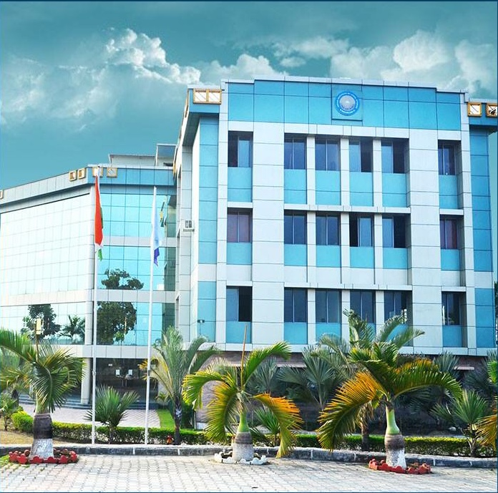INTERDISCIPLINARY REGIONAL SEMINAR on:

**“SOCIO-POLITICO AND ECONOMIC DEVELOPMENT OF NORTH BENGAL AND SIKKIM”**

ORGANIZED BY

DEPARTMENT OF ECONOMICS, POLITICAL SCIENCE AND SOCILOGY

**INDIAN INSTITUTE OF LEGAL STUDIES**

Siliguri, P.O. - Salbari, Dist- Darjeeling, West Bengal, India, Pin – 734002 Phone: +91-353-2574013 / 2574697, Fax: +91 3532574698

Website: www.iilsindia.com,

Email: iilsseminar19@gmail.com

**Dignitaries**

* **MS. MAHESWARI KHARGA, ASST PROFESSOR OF NAMCHI GOVERNMENT COLLEGE AND PHD SCHOLAR, JNU**
* **MR. DEBADITYA DUTTA, PHD SCHOLAR, NBU**
* **MS. RINAN SHAH, SENIOR RESEARCH FELLOW, ASHOKA TRUST FOR RESEARCH IN ECOLOGY AND THE ENVIRONMENT, BANGALORE**

**ORGANISING COMMITTEE**

**Mrs. BINITA RAI (Department of Economics), Contact no: 9002194058/6296903432**

**Ms. DEEPIKA GAHATRAJ (Department of Political science),**

**Contact no: 9650558179/6296903437**

**Ms. VISHAKA BLONE (Department of Sociology), Contact no: 7430913568/6296903442**

**Mr. PRAMOD RAI (Department of Political Science)**

Free Registration

Date of intimation for participation

08-04-2019

**Schedule**

**Date: 12th April, 2019, Time: 11:00 am**

**Venue: Lecture Hall, Indian Institute of Legal Studies**