The Indian Institute of Legal Studies has a vision of creating a community which should be composed of the most committed students who are able to solve the legal and social problems so that they can promote justice and be compassion towards the members of the society. The institute also has the vision of imparting the advocacy skill to the student as this advocacy skill is important while entering into a legal profession. Keeping this mission in mind, the students strives for innovative measures where they learn by enhancing their learning experiences. As an experimental learning process the students of the institute organize various programmes such as “**Youth Parliament**” every year on 26th November (Constitution day) to facilitate the aspiring students to exchange their views on some current issues like “**Right to** **Privacy, Triple Talaq, G.S.T, L.G.B.T Rights**” etc. They participate in **class presentation** in variousmodes such as **PPT, paper presentations, class debates, Poster Presentations**, illustrations etc thus 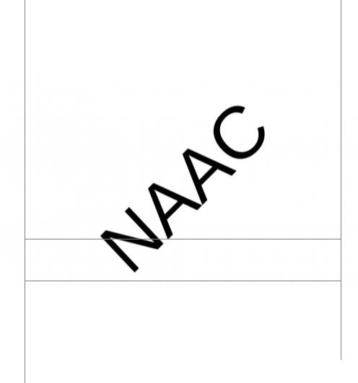enhancing their knowledge. They also have undertaken various **special projects** related to their subject on various fields such as **Human Rights, Criminal law** etc. They have undertaken projects on **Anti Human** **Trafficking, Drugs Abuse, and Domestic violence** and so on. For the purpose of the same they havevisited the **Indo- Nepal Border, Indo- Bhutan Border** under the guidance of the faculties and the SSB at the border. They have taken legal education forward as they shared their knowledge and sanitized the locals of those regions in regards to sensitive issues such as Drugs Abuse, Menaces of Human Trafficking, Domestic Violence etc. By conducting such field visits they have enriched their knowledge and they guide the juniors in the same way. Our senior students also participate in **CLASS TEACHING**, where they take classes of the junior semester in the presence of the faculties thus developing the skill of public speaking. Every year our students organize **SAARC** as well as National **MOOT COURT** Competition, where they themselves select the topic thus again enriching their skill. Our students just do not limit themselves to the classroom studies; they also participate in various programmes, where they gain as well as share knowledge, such as **Traffic awareness programme** with the help of the Metropolitan Police. We have elocution programs in our college for grooming the students for public speaking. Our students attend various workshops on different legal aspects both National as well as International level. The students of IILS have also participated in the Inter-college capacity development programs and IILS has also taken initiative to conduct such programs. Some students have attended 21 days **DIPLOMA COURSE** on Economics social and Development rights in **Katmandu School of Law**, **Nepal**. Our students have also undertaken **SHORT TERM INTERNSHIP PROGRAMME** at **National Human Rights Commission,** **New Delhi**. Our students also contribute their knowledge by writing articles in **IILS QUEST** a studentjournal which is another innovative way of studies. As a practical experience our students visits Court rooms regularly to witness the proceedings of the court.